User Manual



Inventory and Billing
Management System

Developed By:


User manual version: 1.0

Table of Contents
1. General Information 1
1.1 System Overview 1
2. System Summary 2
2.1 Browsing System 2
2.2 Modules 2
2.3 User Access 2
3. Getting Started 3
3.1 Logging In 3
3.2 System Modules 3
4. Master Data 3
4.1 Product 4
4.1.1 Product Unit 4
4.1.2 Product Group 5
4.1.3 Product Category 5
4.1.4 Product 6
4.2 General 7
4.2.1 Vendor 7
4.2.2 Customer 8
4.2.3 Agent 9
4.2.4 Area 10
4.3 License 11
5. Utilities 11
5.1 Purchase 11
5.1.1 Purchase Product 11
5.1.2 Purchase Edit 13
5.1.3. Purchase Return 14
5.1.4. Return Reprint 16
5.2. Sales 18
5.2.1. Product Sale 18
5.2.2. Invoice Reprint 20
5.2.3. Invoice Cancel 21
5.2.4. Sales Return 22
5.2.5. Return Reprint 24
6. Report 25
6.1. General 25
6.1.1. Purchase 25
6.1.2. Daily Sales 27
6.2. IRD 28
6.2.1. Materialized View 28
6.2.2. Sales Book 29
6.2.3. Credit Note 29
6.2.4. Debit Note 30
7. Security 31
7.1. Access Control 31
7.1.1. Login 31
7.2. Setting 32

General Information

System Overview
Inventory and Billing Management System is an online based inventory management system developed by Phye Gan Pvt. This is V1.0 version. This system helps businesses keep track of their stocked products.
The system involves various steps, such as ordering, receiving, storing, and packing goods. The use of hardware and software facilitates tasks like real-time tracking, order processing, and generating reports. By employing an IMS, businesses can efficiently manage their inventory, reduce costs, improve efficiency, and enhance customer satisfaction. The system provides valuable data for informed decision-making, making it a crucial tool for effective supply chain management.
This Inventory and Billing Management System is developed as per the guidelines of the Inland Revenue Department (IRD) and is IRD-approved. Hence, any kind of change in the system requires the approval of the IRD and cannot be changed directly.

System Summary

Browsing System
As the Inventory and Billing management system is an online system, it is not necessary to install it on each computer. To browse the computer must be in the network and connected to the server on which the system is installed.

Modules
The module consists of four modules i.e. Master Data, Utilities, Reports, and Security. Master Data is generally for adding the main data of the system where the master data module consists of three sub-modules i.e. Product, General, and License.

User Access
As per requirement, different users can be created with different user access. For example, a user can be created with administrative privilege that can do everything in the system, a user with data entry privilege, who can enter data and view data, and similarly user with only view privilege, who can view only reports.

Getting Started

Logging In
To log in to the system, the user can browse the system through any browser as mentioned in the previous section. The user must enter the local URL: 192.168.1.5/ims(mean to be changed if ip of the server is changed ). After this, a login page is displayed where the user can enter a username and password to access the system.
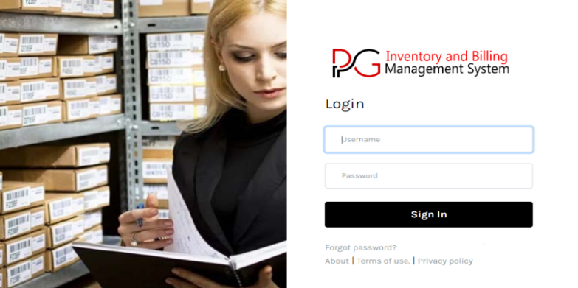

System Modules
After a valid login from the account user, we will get four modules, Master Data, Utilities, Reports, and Security.
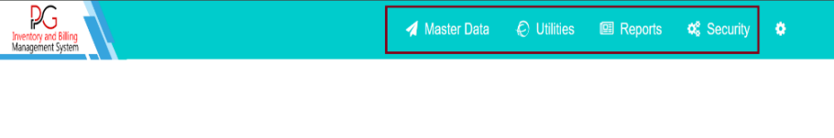

Master Data
This module is for entering the main data in the system. This module consists of three sub-modules i.e. Product, General, and License.
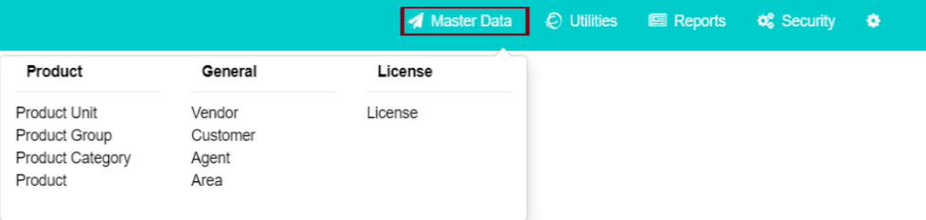

4.1 Product
This Sub-module consists of menus like Product Unit, Product Group, Product Category, and Product. This sub-module helps to add or edit Product units, groups, categories, etc.
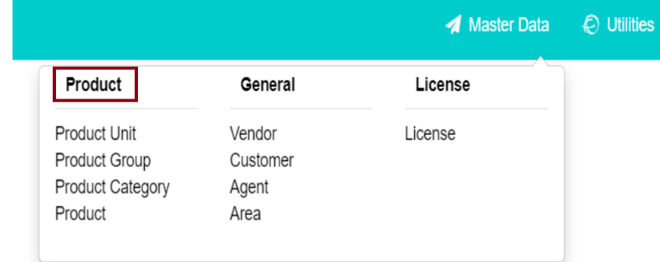

Product Unit
The product Unit module is for adding and editing product units. Click on the Product Unit as shown in the following image.
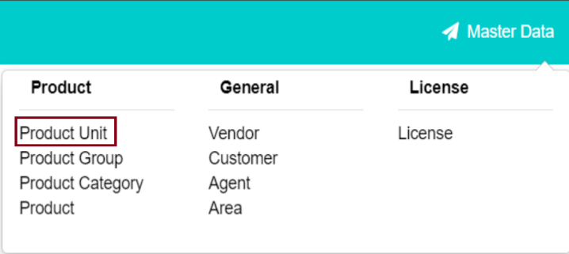

After you click on the Product Unit the following table is displayed. Fill in the Unit name in the button given below the unit’s name then click on the Add button.

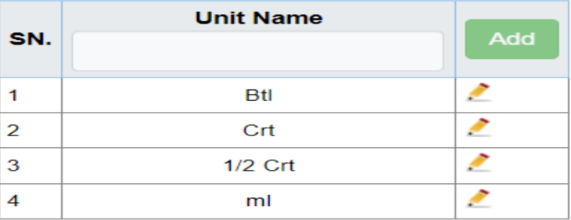

The User Management Module is for assigning user roles to employees. You must add employee details before assigning a user role.

Product Group
This menu is for adding a specific group of products. Click on the Product Group as shown in the following image.
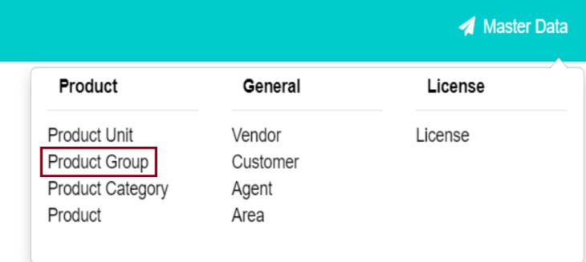
After you click on the Product group following table is displayed. Then enter the group code and group name, also user can also set the status as active or inactive. Then click on the Add button to save the data. As well as users can edit the data.
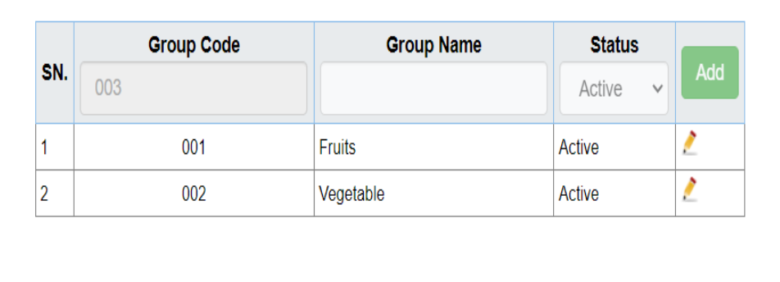

Product Category
Here, in this menu, you can add a product category. Click on the Product Category.
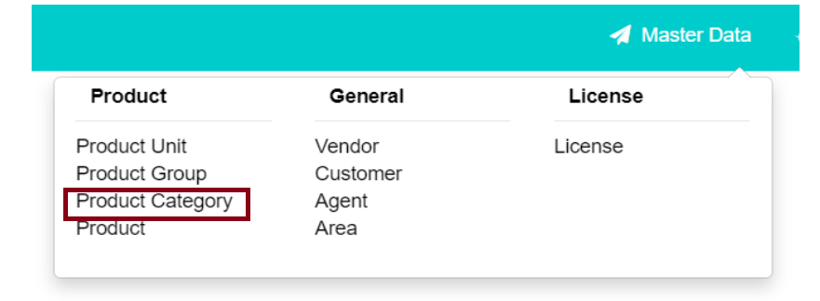

After you click on the Product group following table is displayed. Select the group and click on the load button, then a following table is generated where the user can add a product category.
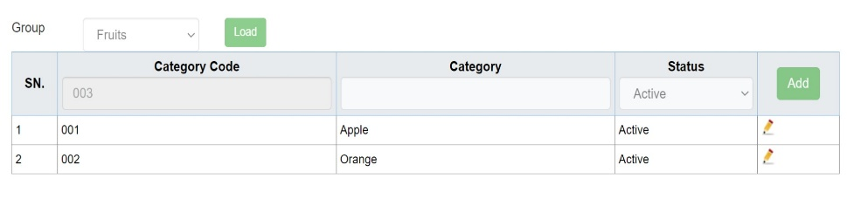

Product
The product menus are for adding products and editing products. Click on the product menu as shown in the following image.
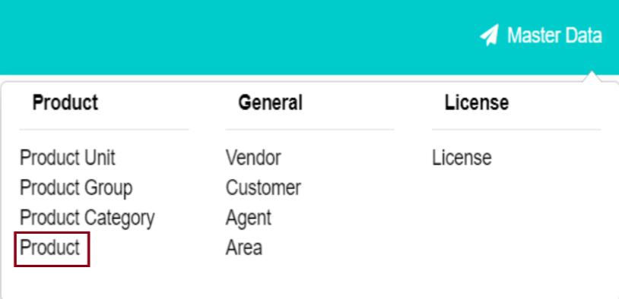
After you click on the Product group following table is displayed.
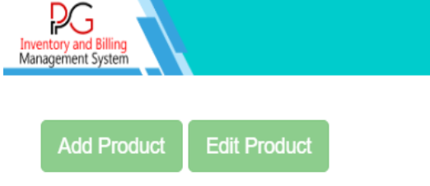
Click on the Add Product button to display the following table. Fill in the given table then click on the save button.
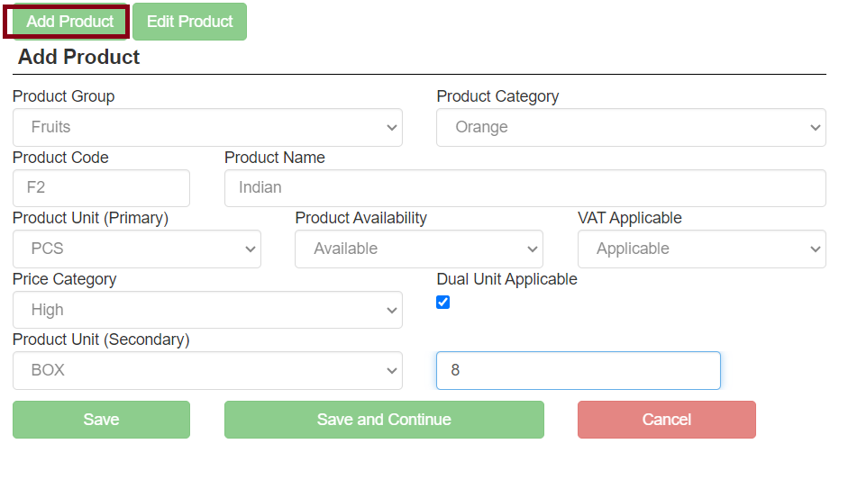
Click on the Edit product button, Select product group and product category then click the filter button to display the table.
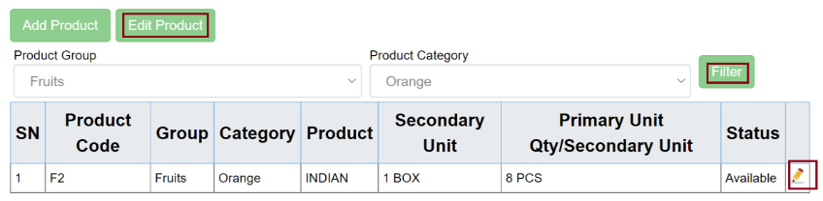

General
General is another sub-module of Master Data where we can enter the personal information of Vendors, Customers, and Agents. Here we can add and edit the data of each menu.
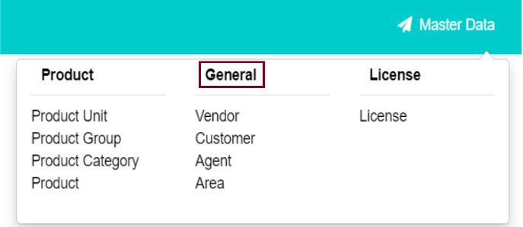

Vendor
This menu helps to add and edit the vendor. The user must click on the Vendor as shown in the given image.
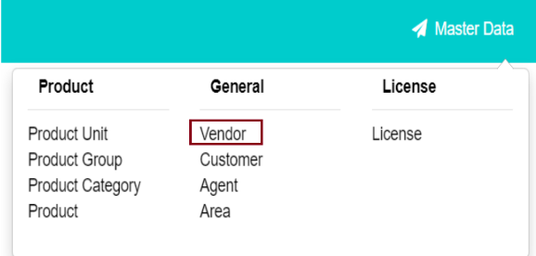
After the User clicks on the vendor menu the following table is displayed. The User needs to click on the Add More button to add a new vendor.
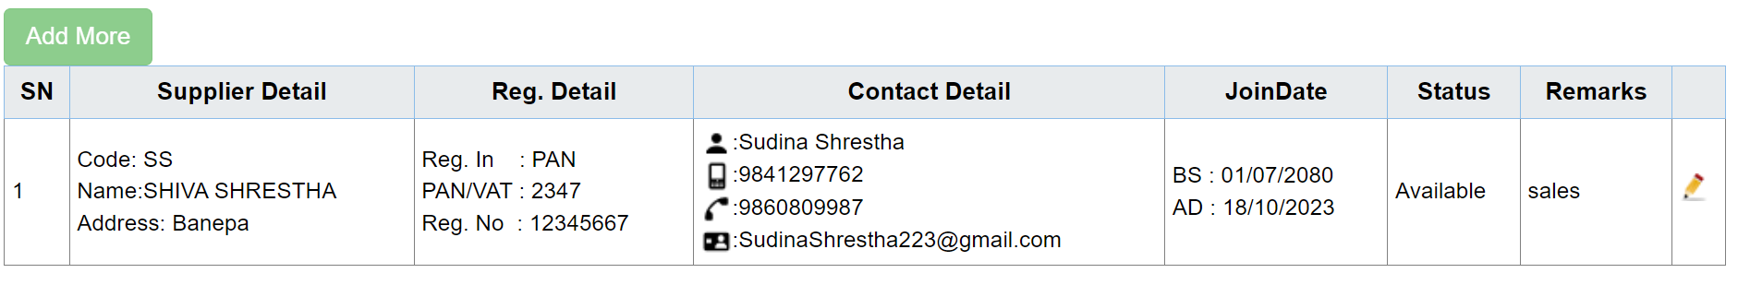

After you click on the Add More button the following table is generated where the user needs to fill up the given details and then click on the save button to save the data.
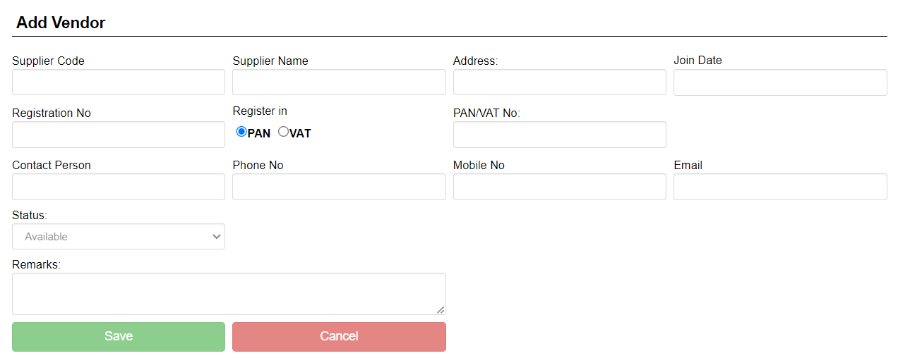

Customer
This menu helps to add customer details. The user must click on the Customer as shown in the given image.
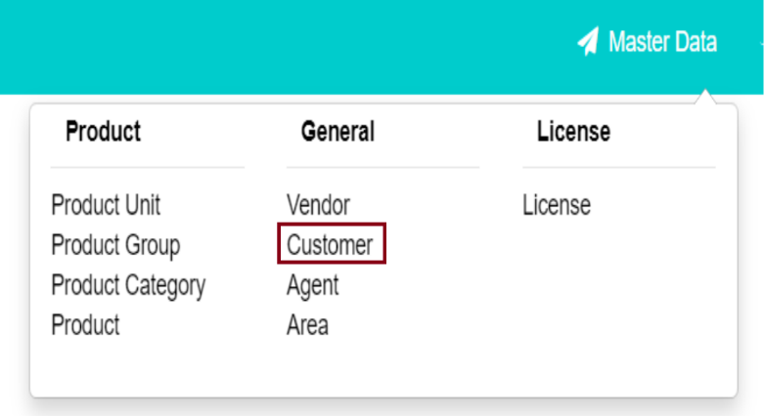
After the User clicks on the Customer menu the following table is displayed. Then the user needs to click on the Add More button to add a new customer. Users can also edit the data.
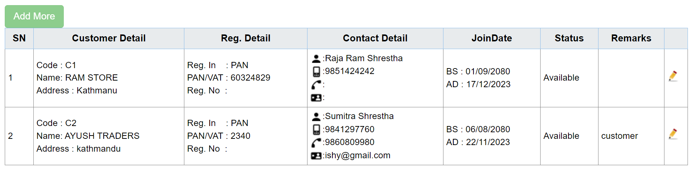
After you click on the Add More button the following table is generated where the user needs to fill up the given details and then click on the save button to save the data.
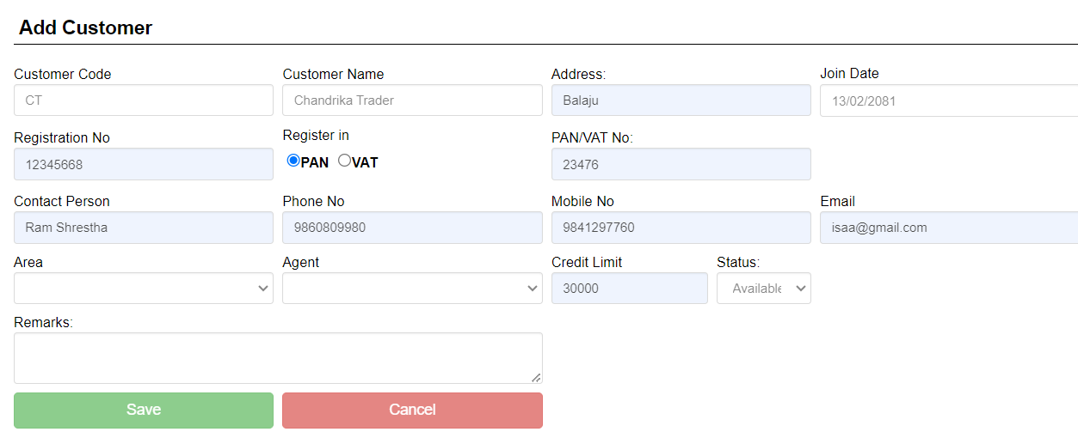

Agent
This menu is for adding new agents. Click on the Agent menu as shown in the image.
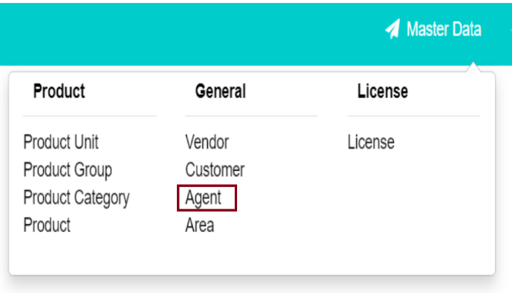
After the User clicks on the Agent menu the following table is displayed. Then the user needs to click on the Add More button to add a new Agent. Users can also edit the data.
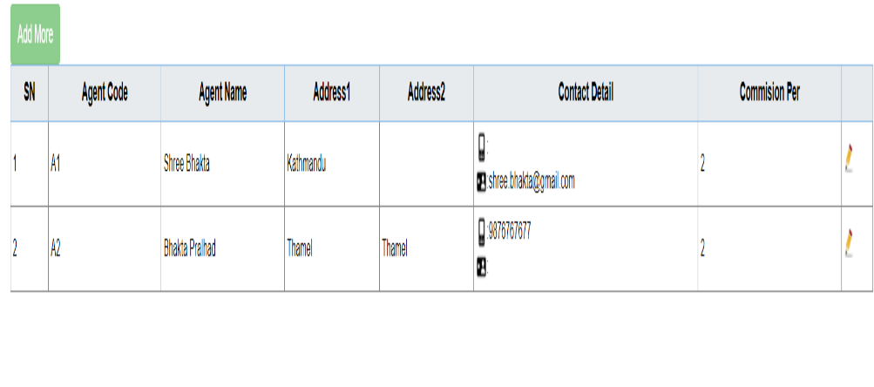

After you click on the Add More button the following table is generated where the user needs to fill up the given details and then click on the save button to save the data.
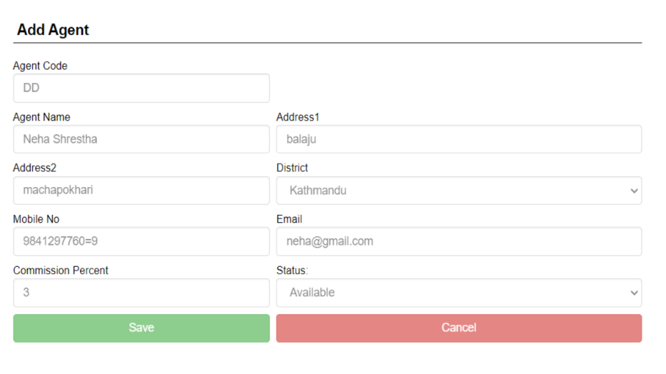
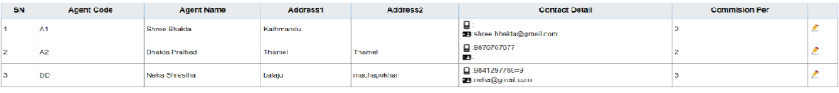

4.2.4 Area
The Area menu is for adding a new area or adding a location. Click on the Area menu as shown in the given figure.
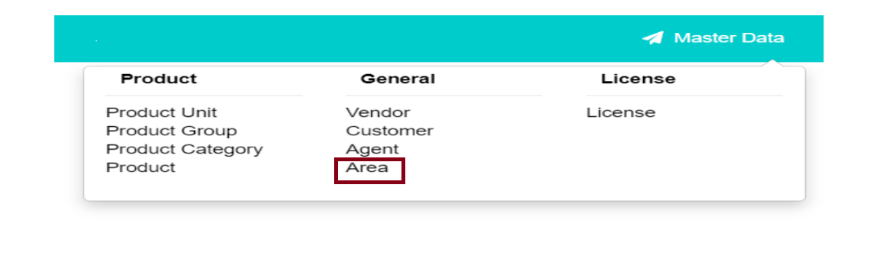
After the User clicks on the Area menu the following table is displayed. Then the user needs to click on the Add More button to add a new Agent. Users can also edit the data.
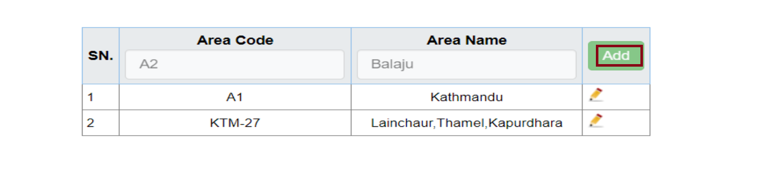

License
This module presents the software License details. Click on the License menu.
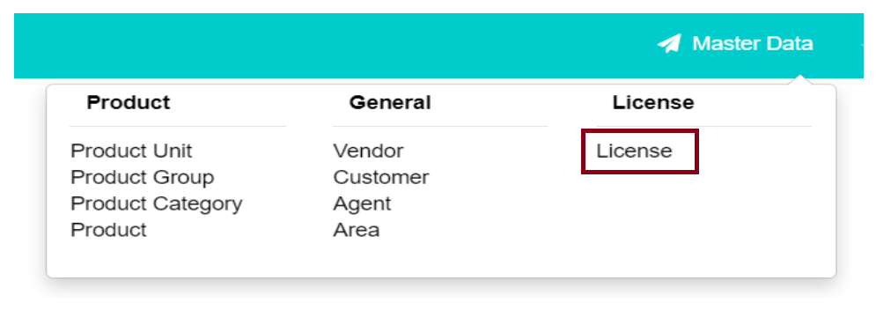
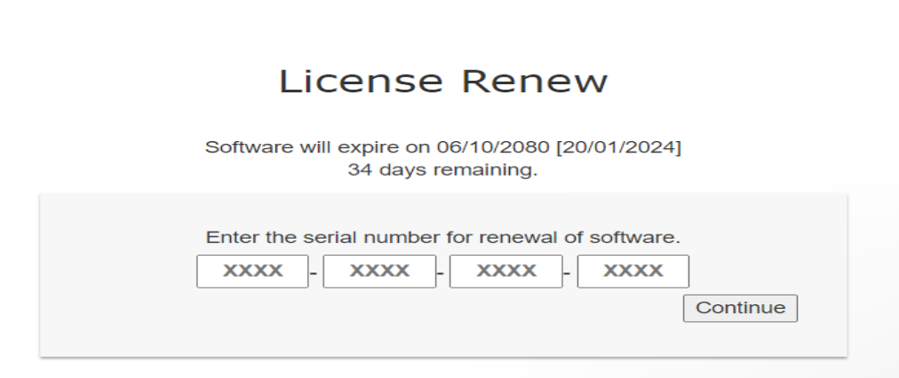

Utilities
The Utilities module is for frequently changing data where it has two sub-modules i.e. Purchase and Sales module.
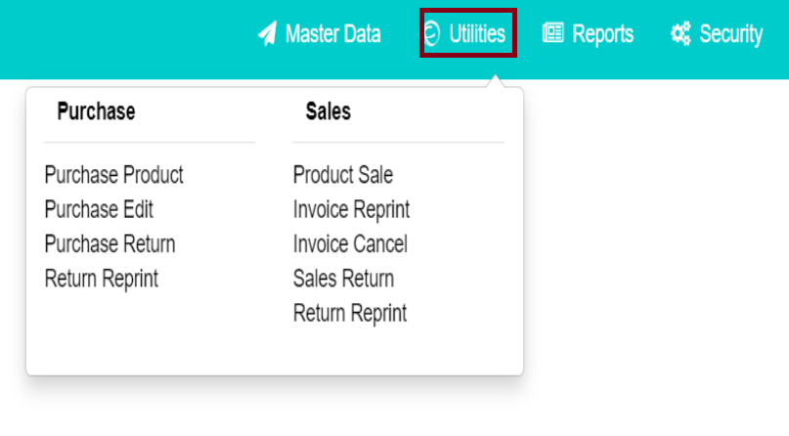

Purchase
This sub-module is only for purchase. This module has four menus i.e. Purchase Product, Purchase Edit, Purchase Return, and Receipt Reprint.

Purchase Product

Click on the Purchase Product as shown in the following image.

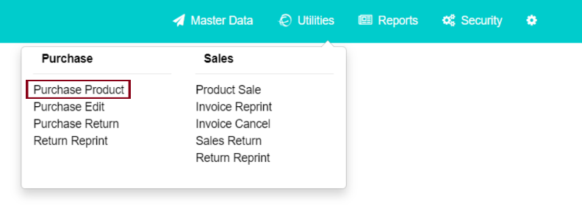
After you click on the Purchase Product following table is displayed, then fill up the given table with the right data. You can select the ‘Sales Type’ as either Cash or Credit. The product name is displayed automatically if its code is entered, or the code is generated automatically if the product name is selected. Then provide the quantity and rate, and the amount is generated automatically. Click on the Add button.
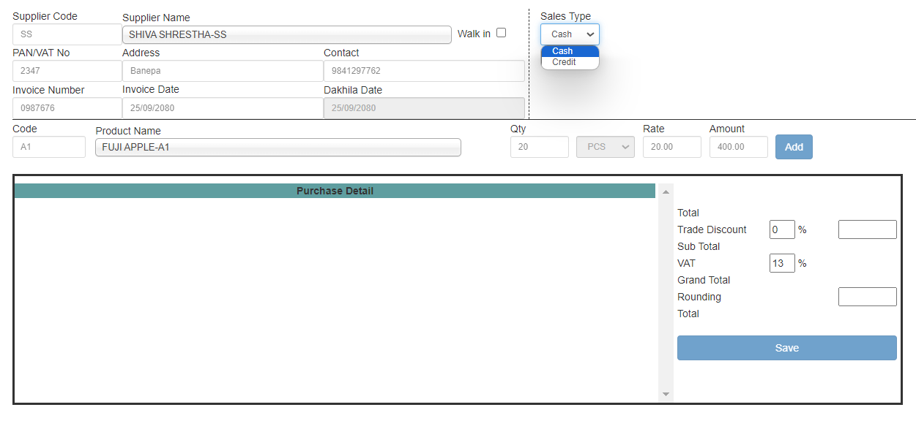
The data is shown in the purchase detail table. Then click on the Save button if all the required data is filled.
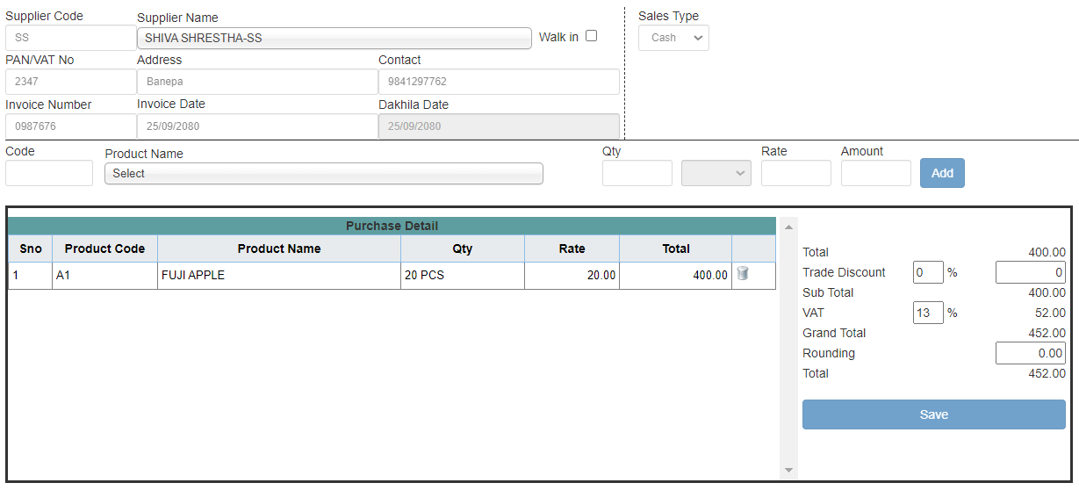
If a non-regular customer purchases the product, please select “Walk-in”. As the entire process is like the previous one.
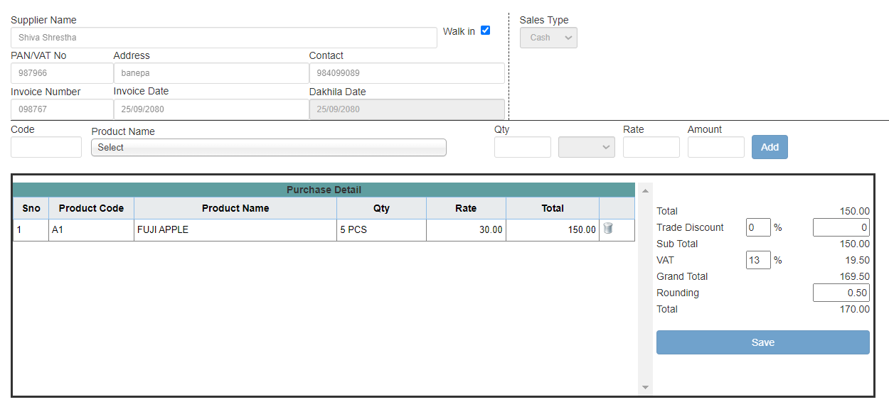

Purchase Edit
This menu is for editing purchase data. Click on the Purchase Edit as shown in the given image.
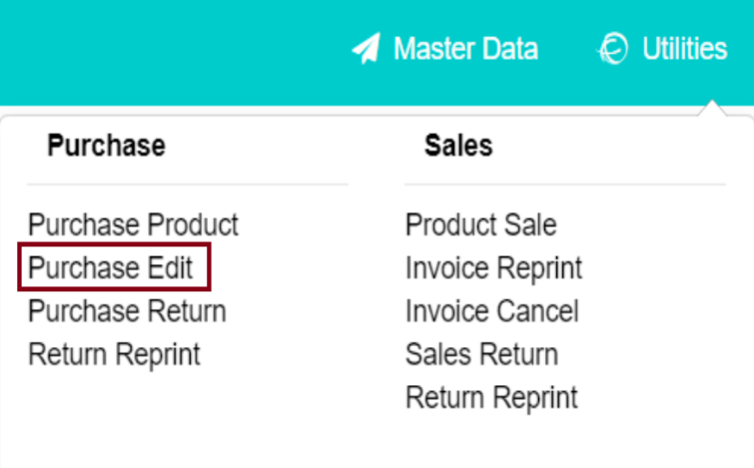

After you click on the Purchase Edit the following table is generated.
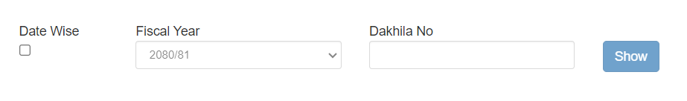
If we select Date Wise, then it will show the From Date and To Date where the user must fill in the date to view purchase details date wisely. Click on the Show button to display the purchase details and select the edit symbol to edit the data.
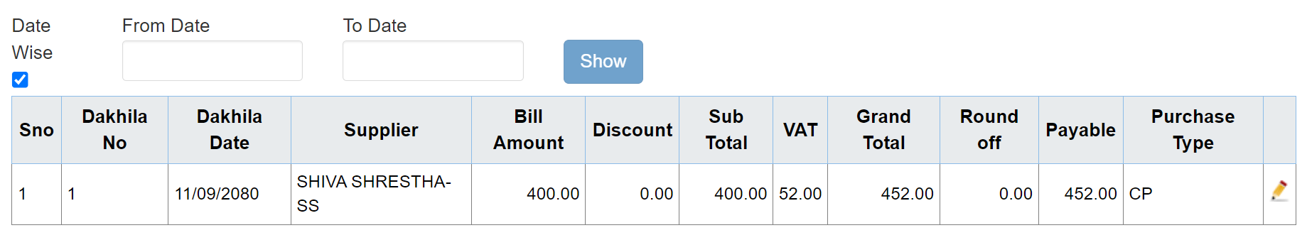
If Date wise is not selected then it shows Dakhila No, where the user must enter the Dakhila No of purchase.
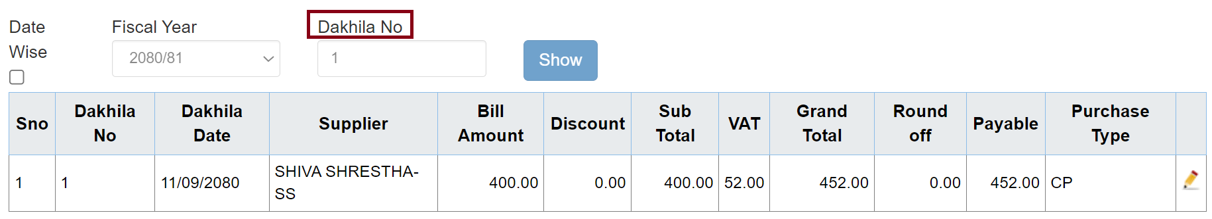

5.1.3. Purchase Return
This menu is for returning purchases, Click on the Purchase Return.
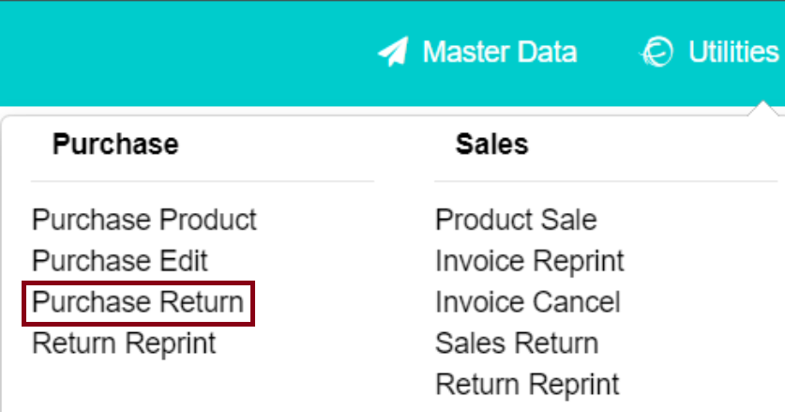
After you click on the Purchase Return menu the following table is generated.
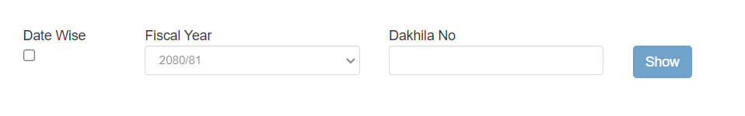
To view the data, you may select Date-wise or fill in the ‘From Date’ and ‘To Date’ fields.
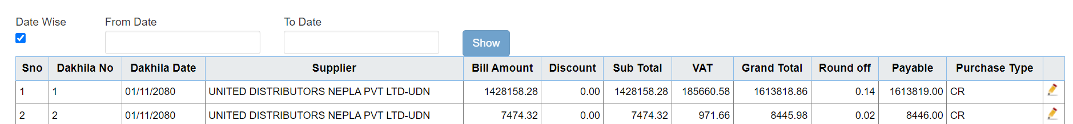
After you click on the edit button the following page will be displayed.

You can select Debit note type as Cash and Credit
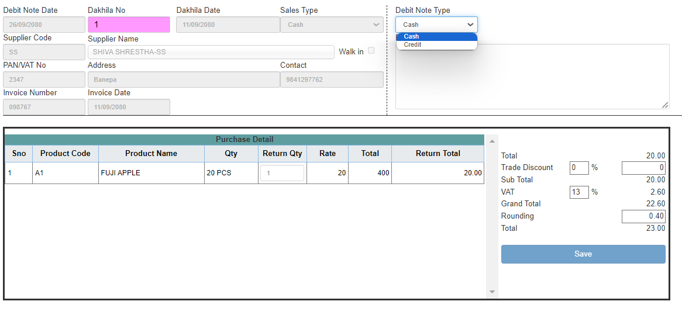
Write down the purchase return note in the ‘Return Note’ field. Add the Return Quantity, then the amount is generated automatically.
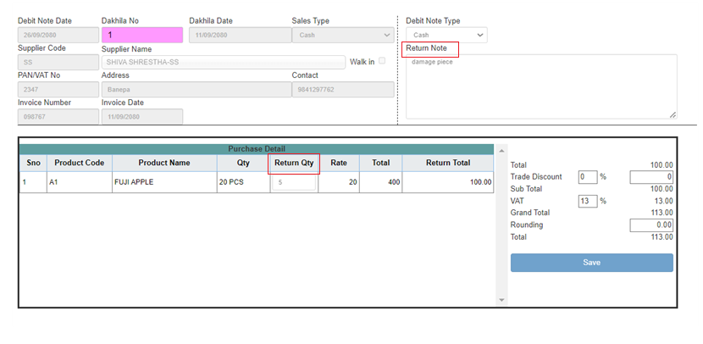
After you click on the ‘Save’ button the following table is displayed.

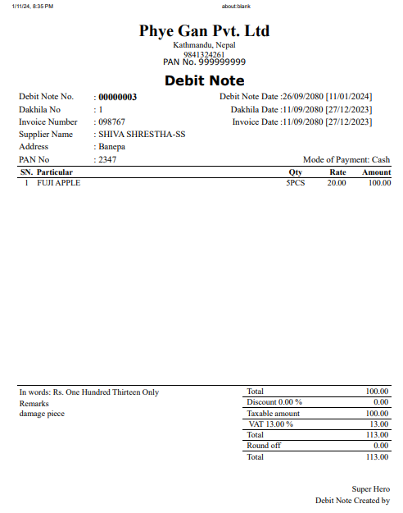

5.1.4. Return Reprint
This menu consists of return receipts for returning products. Click on the Return Reprint menu as shown in the following image.
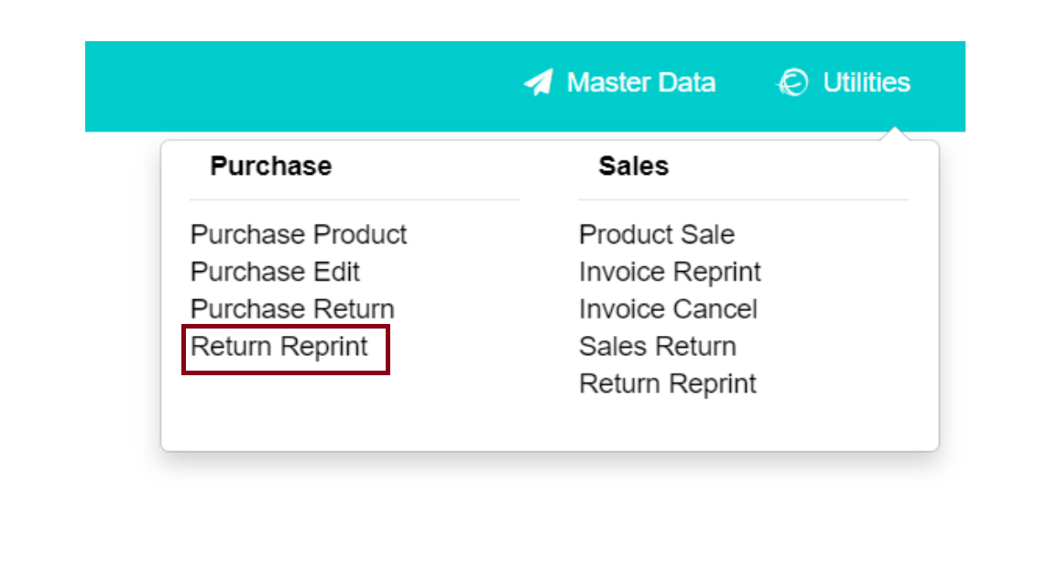

After you click on the Return Reprint following table is displayed.
Select Date Wise, fill in the date, and click on the show button then data will be displayed as shown in the following table. Then click on the print button to print the receipt.
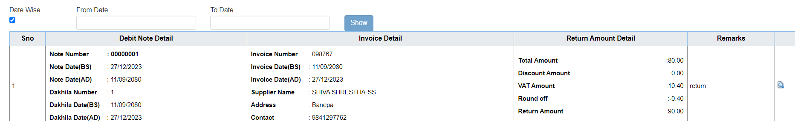
Click on the print button following page is displayed.
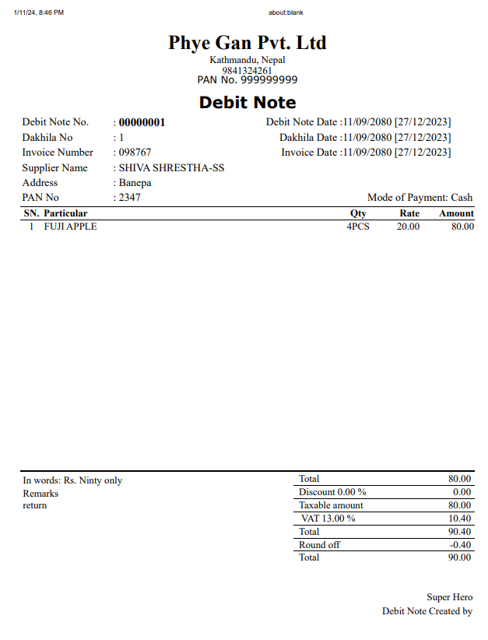

5.2. Sales
This sub-module is only for Sales. This module has five modules i.e. Product Sale, Invoice Reprint, Invoice Cancel, Sales Return, and Return Reprint.
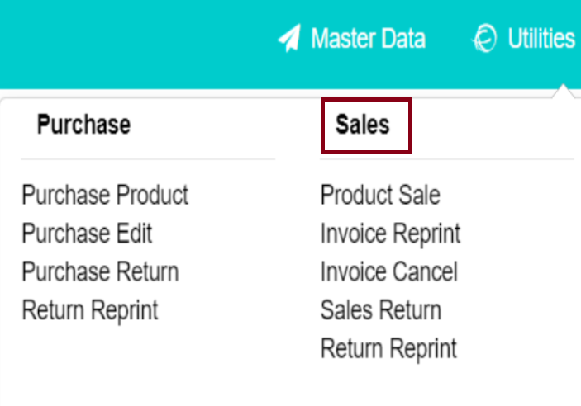

5.2.1. Product Sale
This menu is for adding sales products. Click on the Product Sale as shown in the following image.
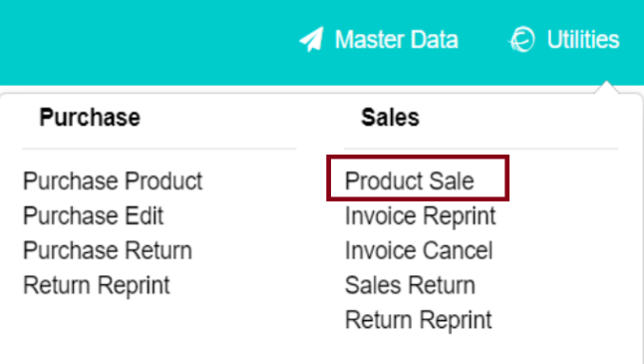
After you click on the Product Sale the following table is displayed. Fill in the given details then click on the Add button. Here you can select sales type Cash or Credit.
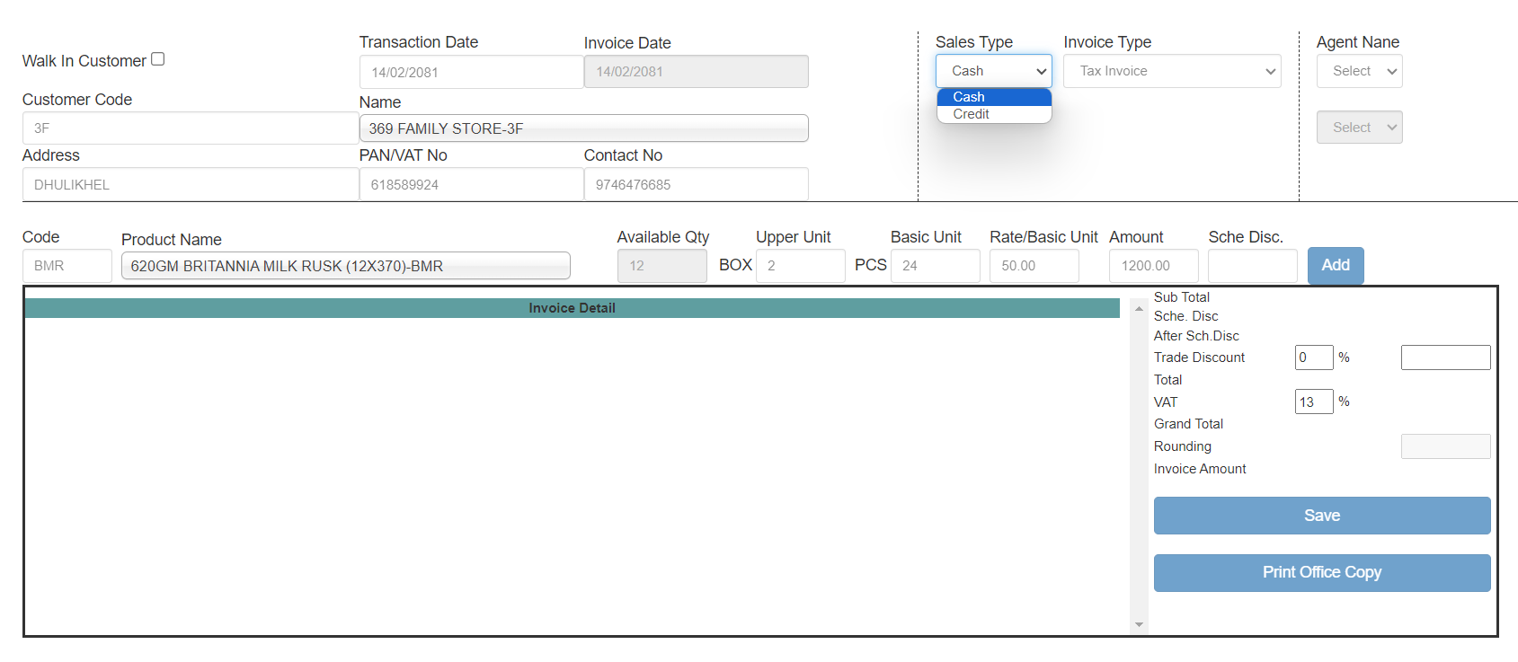
Select ‘Tax Invoice’ if the tax is included in the product otherwise, select ‘Exempted Invoice’ if the tax is not included.
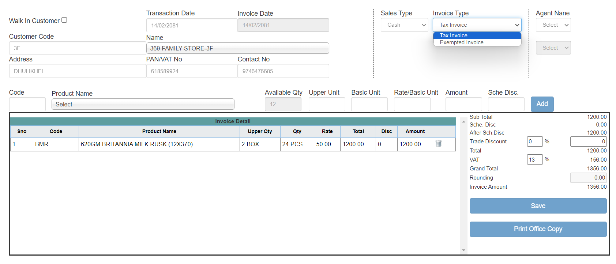
Only the available quantity, shown in the ‘Available Qty’ field, can be purchased. Enter the number of boxes in the upper unit field, and the number of pieces per box will be generated automatically. Then, provide the rate, and the amount will be calculated automatically.
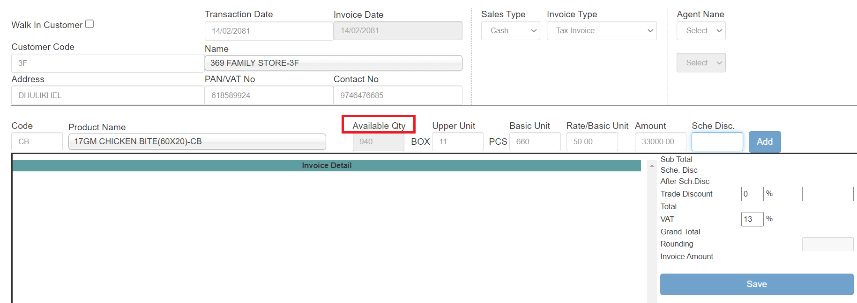
You can select Agent from the ‘Agent Name’ field.
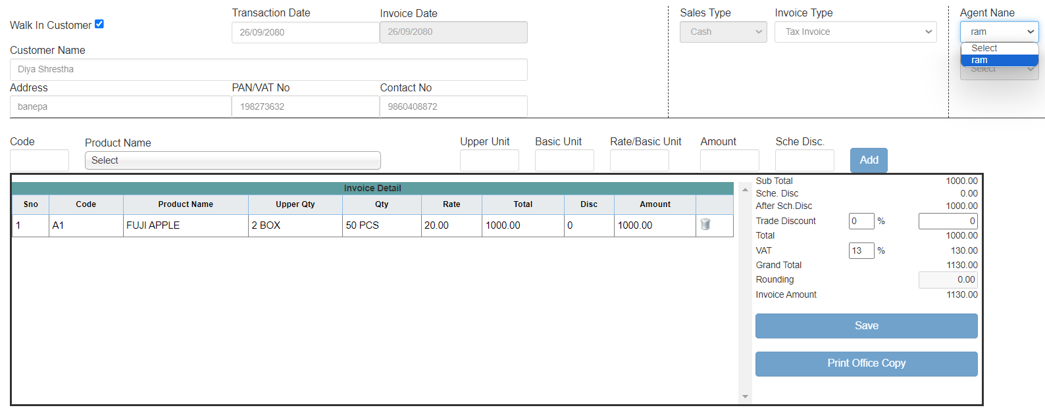

After the Add button is clicked, data is displayed in invoice details then click on the Save button if all the required fields are filled. Then the invoice is generated.
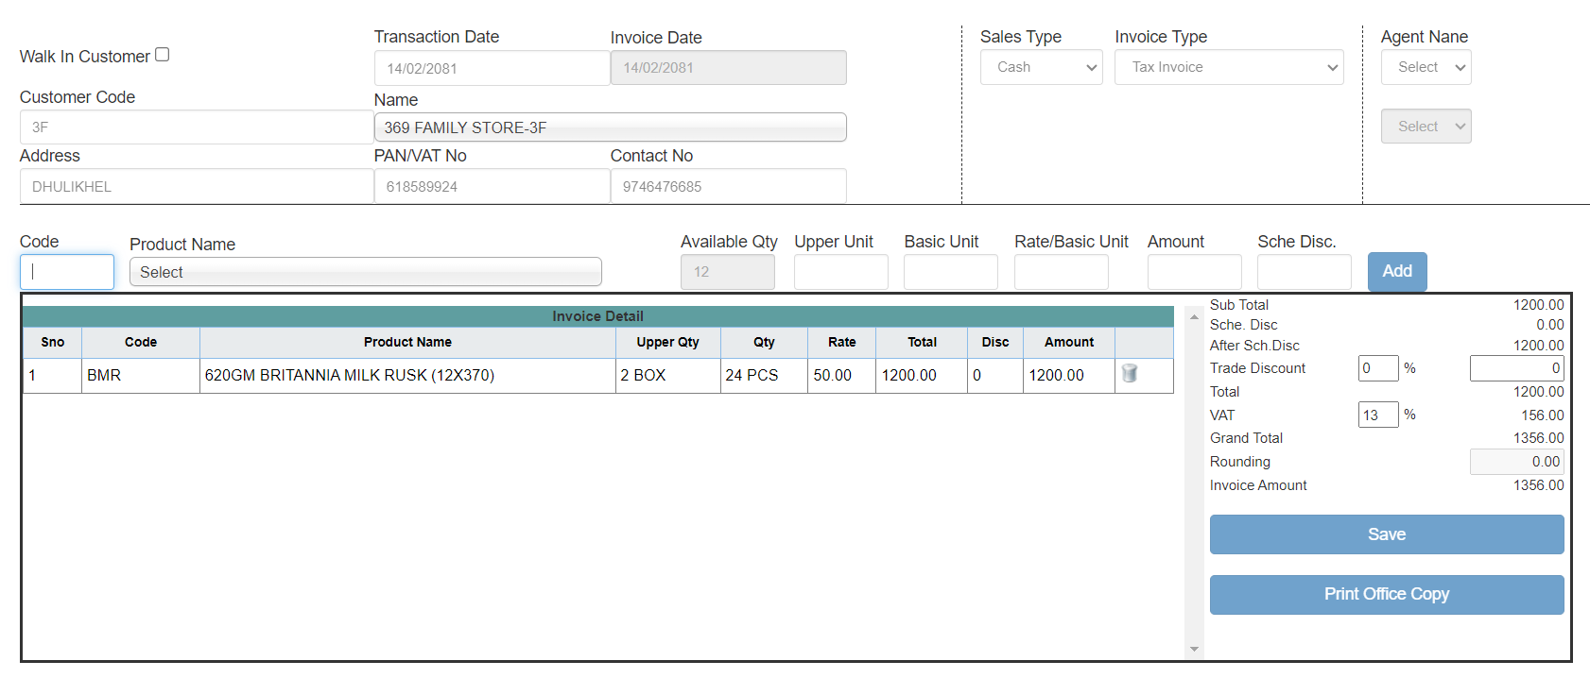

5.2.2. Invoice Reprint
This menu is for reprinting the invoice. Click on the Invoice Reprint menu as shown in the following image.
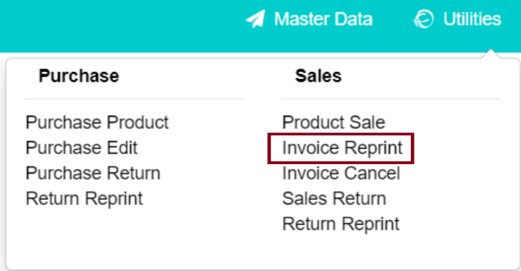
After you click on the Invoice Reprint following table is displayed. Select date wise or invoice not then click on the show button. After the Sales detail is shown click on the print button to print the invoice.
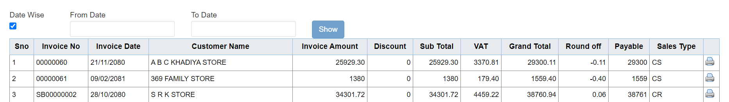
Click on the Print button to display the following page.
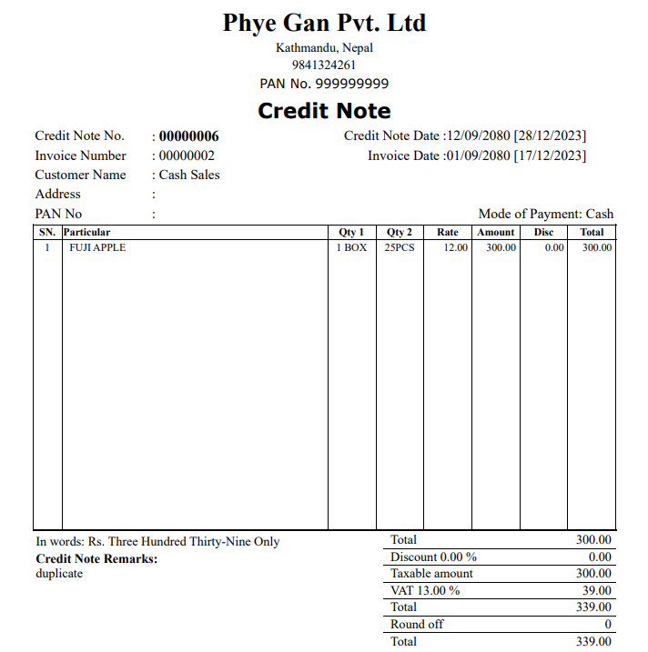

5.2.3. Invoice Cancel
This menu is used for canceling invoices. Click on the Invoice Cancel menu as shown in the following image.
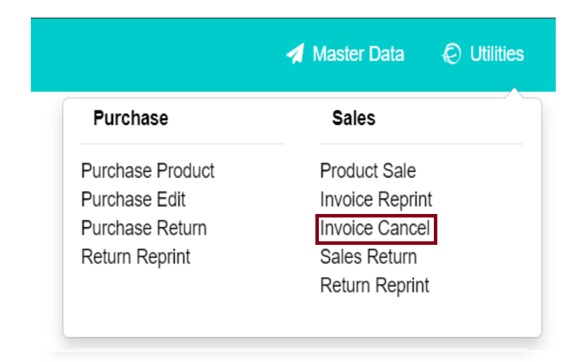
After you click on the Invoice Cancel menu following table is displayed. Click on the Show button to display the data, then select the invoice you want to cancel.
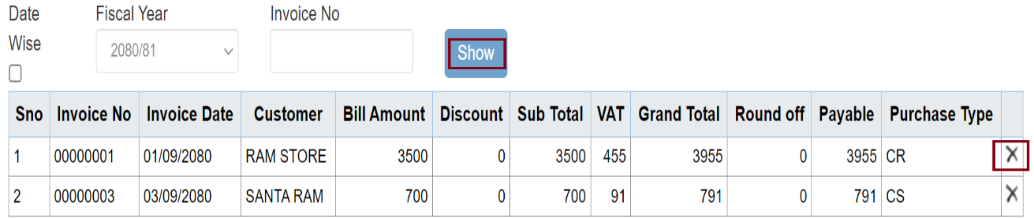
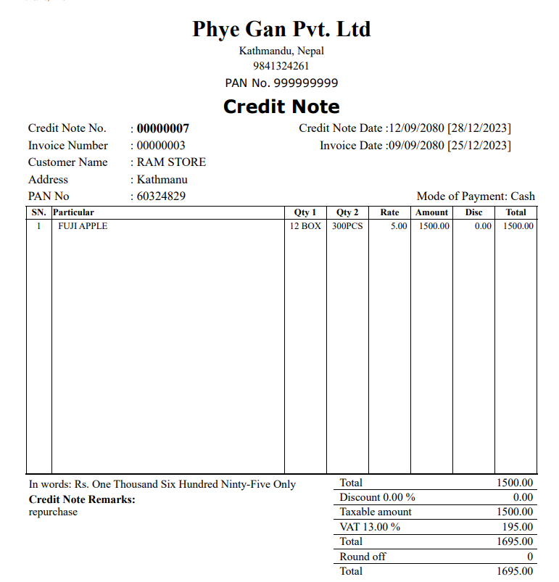

5.2.4. Sales Return
The sales Return menu is for managing sales return items. Click on the Sales Return menu as shown in the image below.
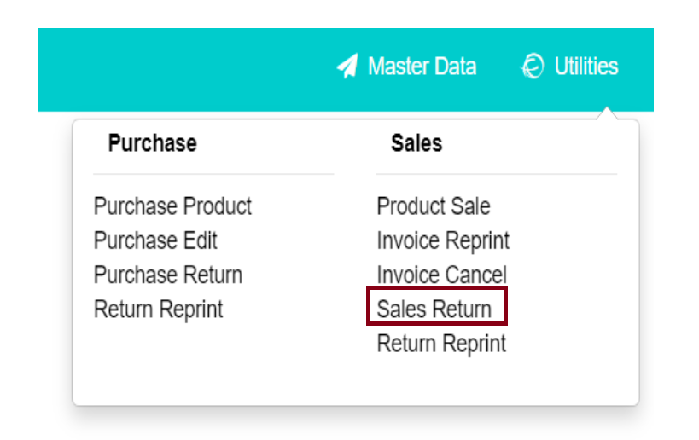
After you click on the Sales Return menu the following table is displayed. You may select Date wise or can enter Invoice No then click on the show button to display the sales data.
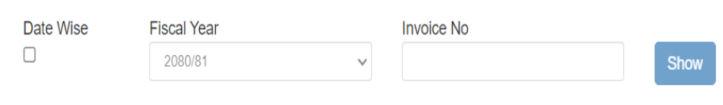
Click on the arrow icon representing Sales Return at the right corner of the table.
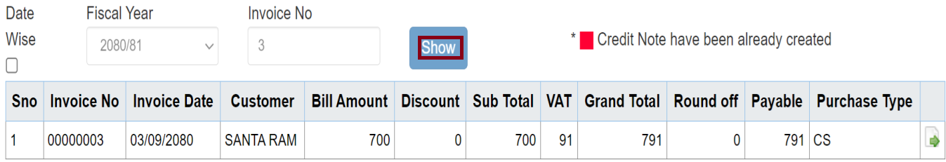

After clicking the arrow icon, a table will be generated where you must enter the return quantity. You can write the return reason in the “Return Note” field. In the invoice detail table, enter the return quantity as the rate is generated automatically. Once all the data is filled in, click the saved button.
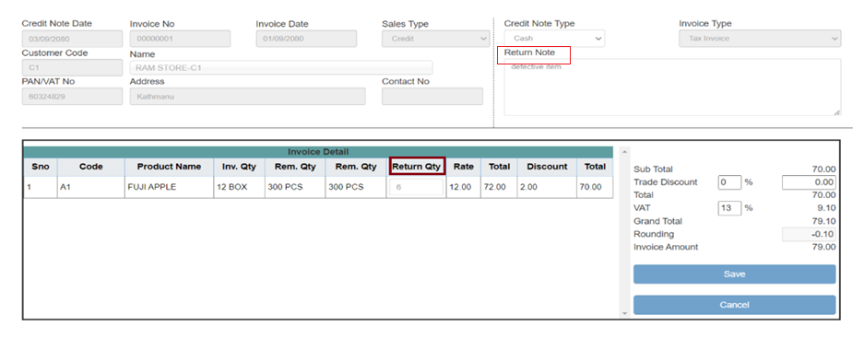
After the data is saved the following table is generated where the red color indicates that the credit note has been already created.
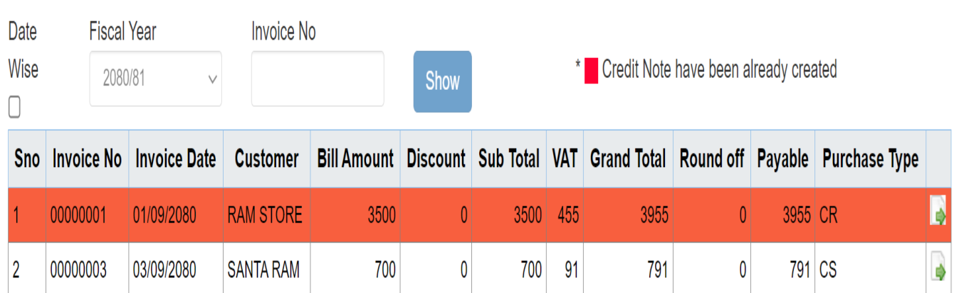

5.2.5. Return Reprint
This menu is for generating sales return credit notes. Click on the Return Reprint menu as shown in the image.
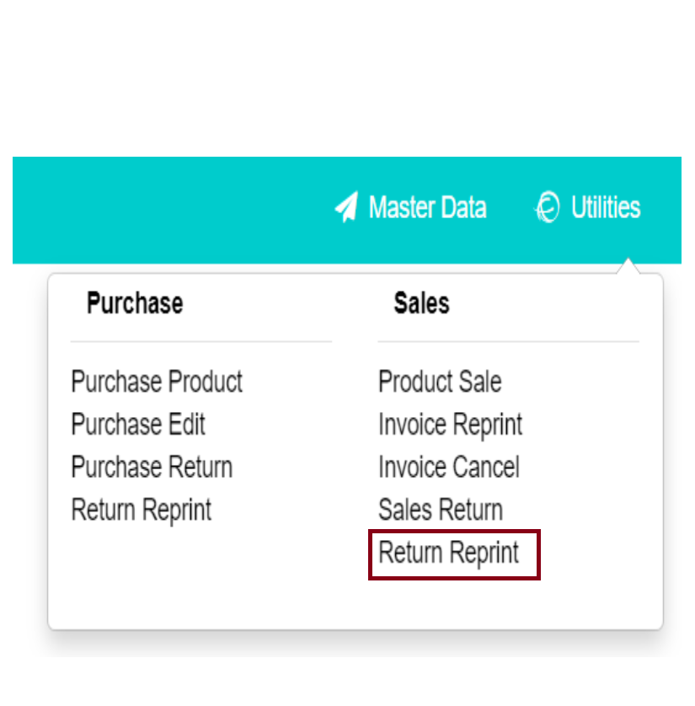
After you click on the Return Reprint menu following table is displayed. Click on the Show button to generate credit note details.
After you click on the Show button the following table is displayed. To print the Credit Note, click on the print icon.
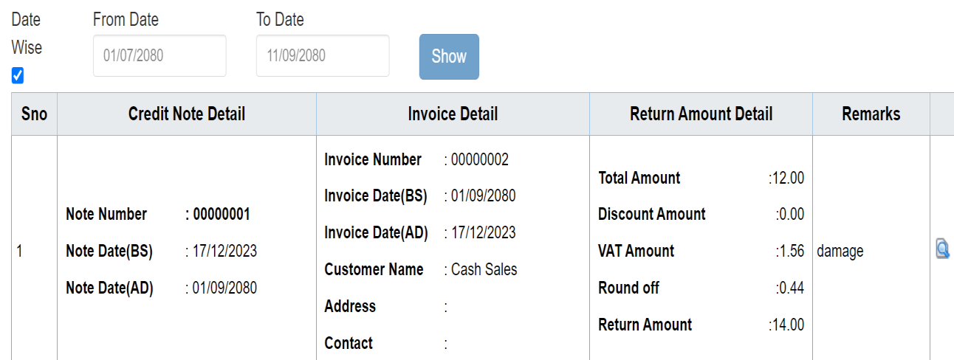
After you click on the print icon, a Credit Note is generated for printing.
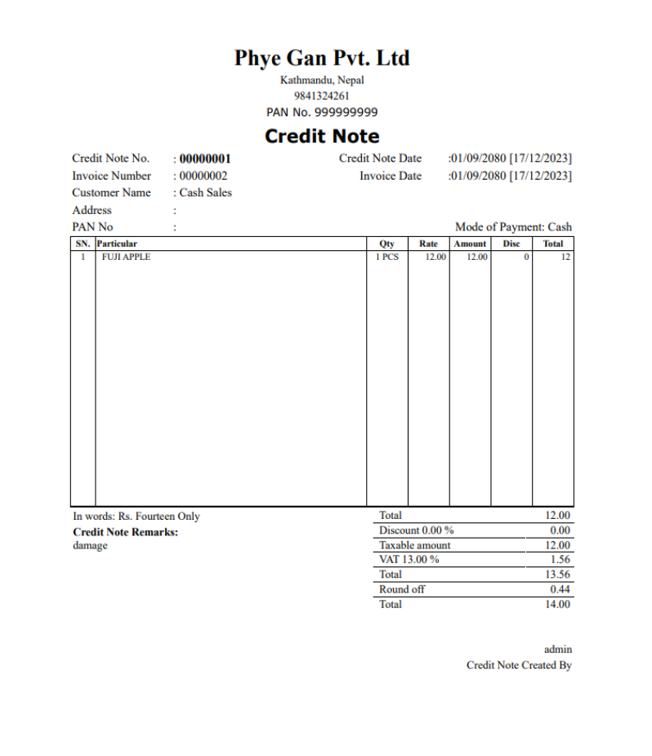

Report
This module contains the purchase and sales records. This module presents two menus General and IRD.
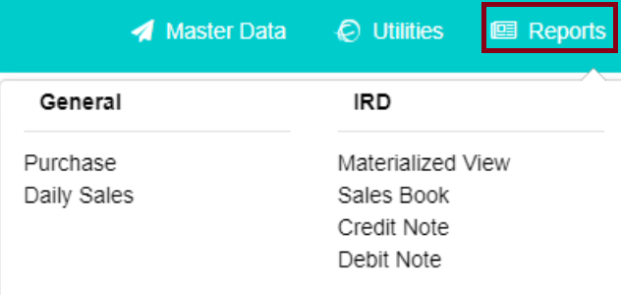

6.1. General
This sub-module contains the Purchase and Daily sales report.

6.1.1. Purchase
This menu presents the record of all the purchases. Click on the purchase as shown in the image below.
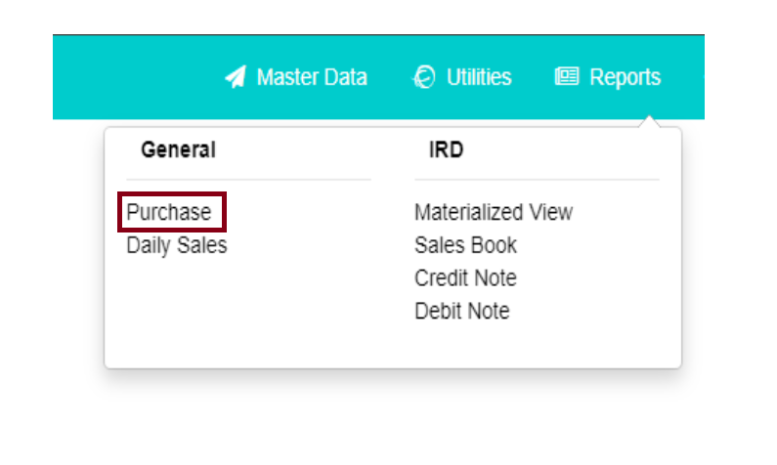
After you click on the Purchase menu the following table is generated where you must enter the date and then select the Show button to view the purchase records.
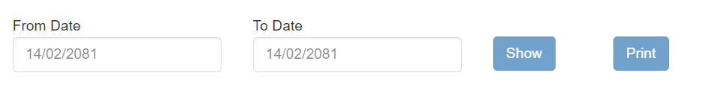
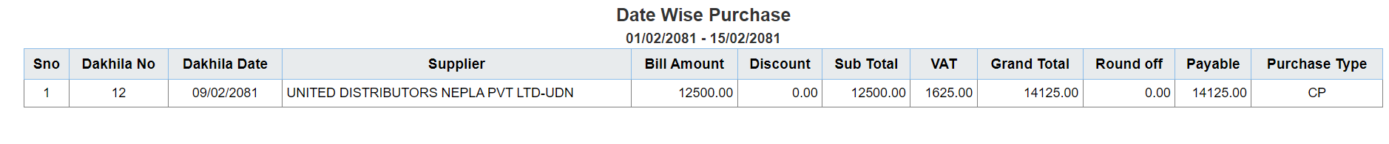
To print the record, click on the print button.
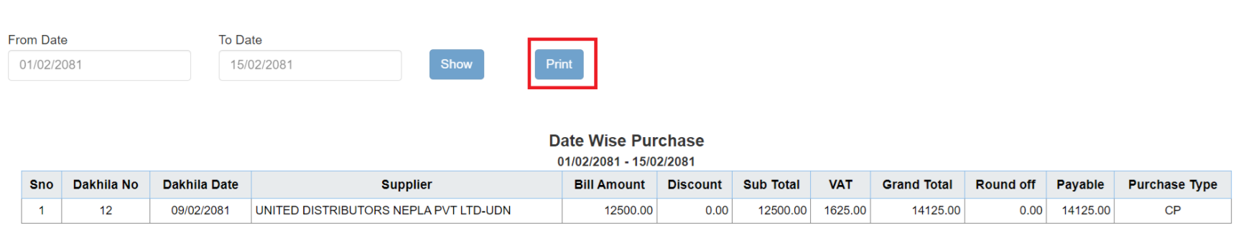
After you click on the Print button the following page is generated.
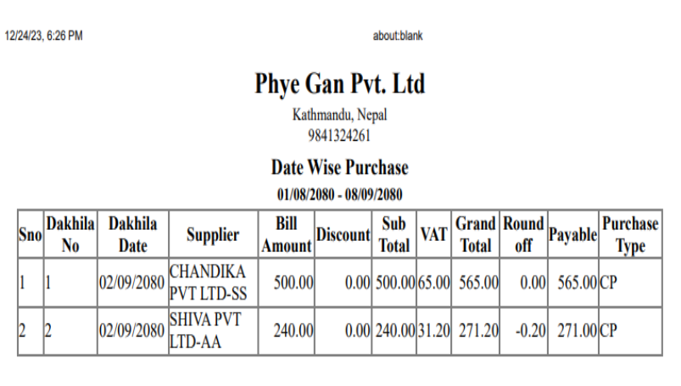

6.1.2. Daily Sales
Daily Sales records are present on this menu. Click on the Daily Sales menu as shown in the image.
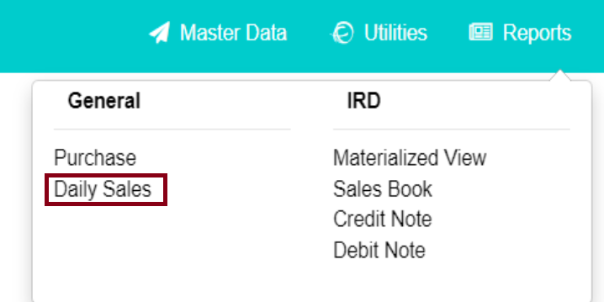
After you click on the daily sales menu following page is generated, select the date, and click on the list button to display the report.
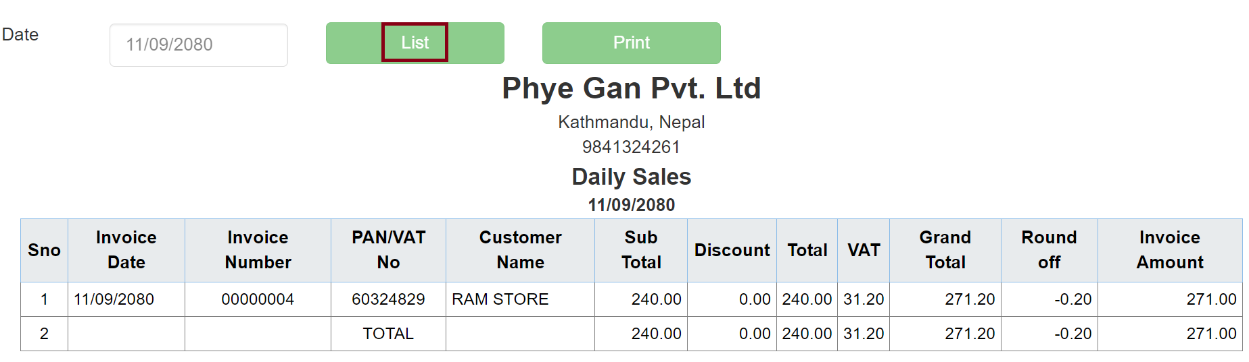
Click on the Print button to print the data.
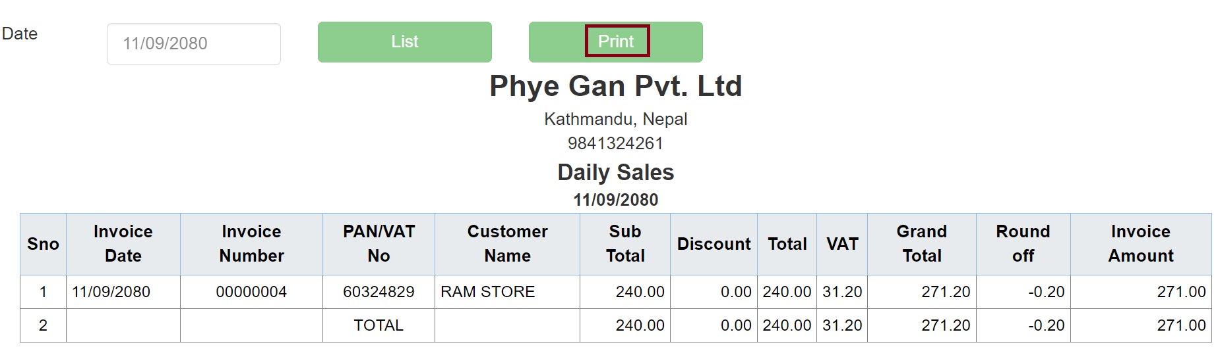
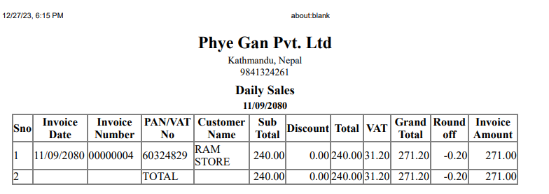

6.2. IRD
IRD refers to the Inland Revenue Department. This module contains reports related to tax, sales, credit, and debit. There are four menus i.e. Materialized View, Sales View, Credit Note, and Debit Note.

6.2.1. Materialized View
To view the materialized report, click on the Materialized View menu as shown in the image below.
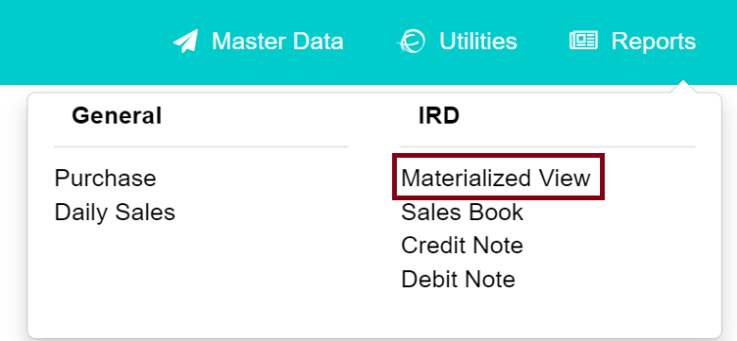
After you click on the materialized view following table is generated. Here you must enter a specific date and invoice type i.e. Tax invoice or Exempted invoice then click on the view button to generate the report.
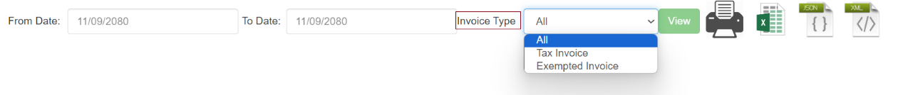
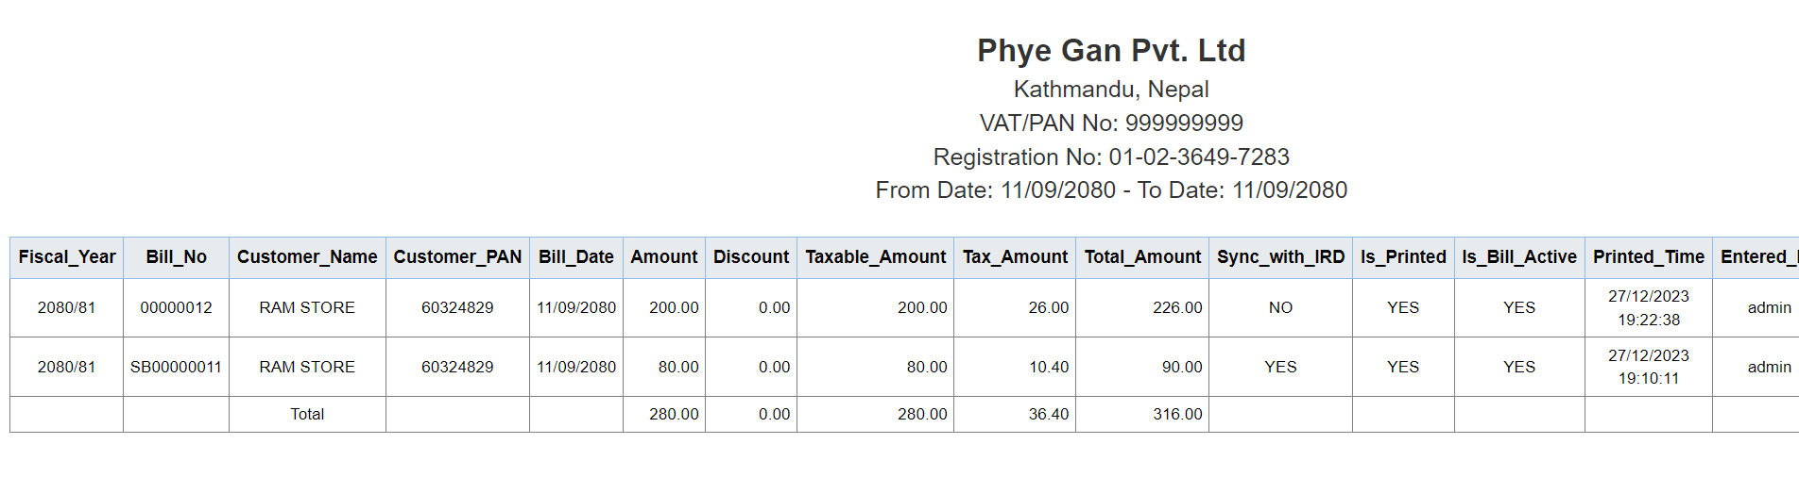

6.2.2. Sales Book
This menu presents the product sales record. Click on the Sales Book menu.
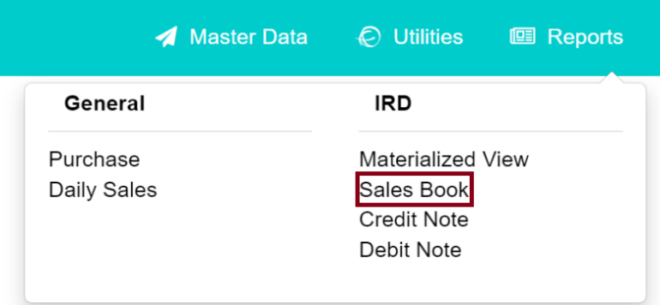

After you click on the Sales Book menu following table is generated, Select the specific date then click on the view button to display the report.
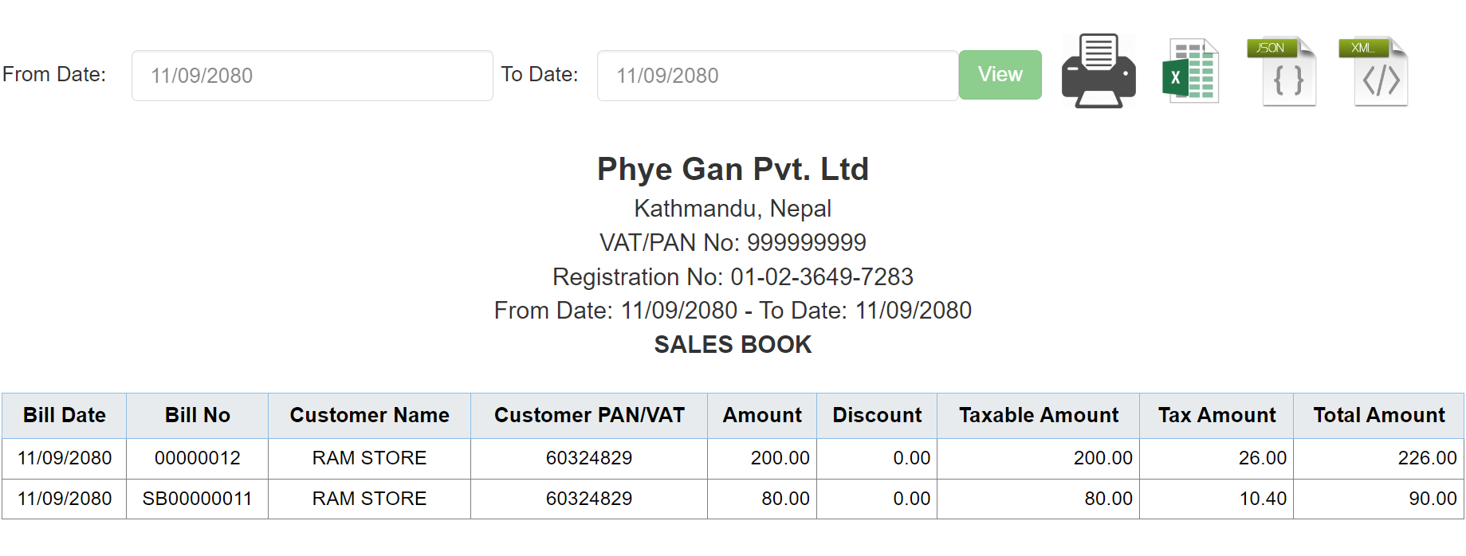

6.2.3. Credit Note
This menu presents the record of Sales returns. Click on the Credit Note menu.

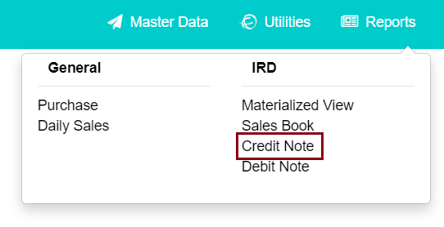
Select Date and Click on the view button.
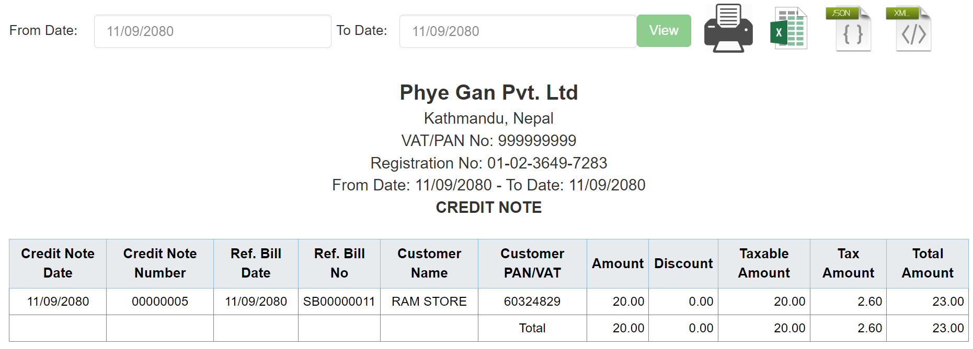

6.2.4. Debit Note
A Debit Note is generated after the purchase is returned. Click on the Debit Note menu to view the report.
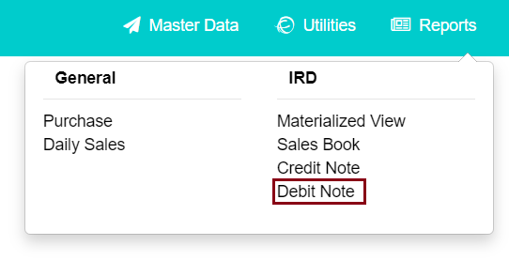
Select the Date and click on the view button.
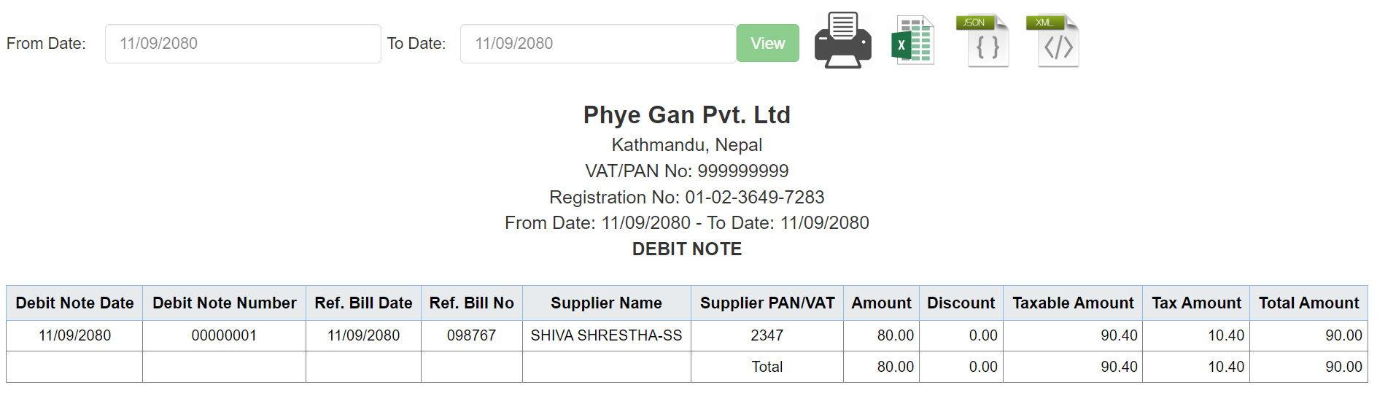

Security
This module consists of two sub-modules i.e. Access Control and Setting.
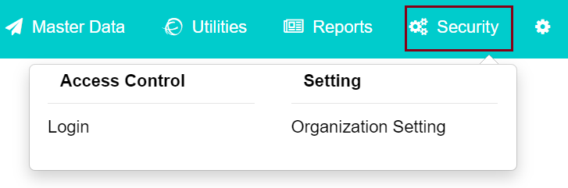

7.1. Access Control
This sub-module is designed to provide access control. This module consists of one menu i.e. Login.
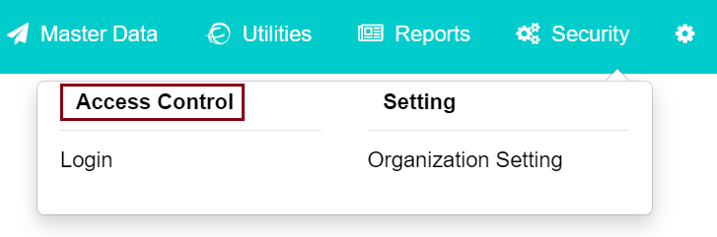

7.1.1. Login
Click on the Login Menu then the table is generated.
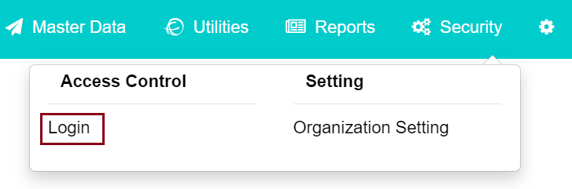
Click on the Add New button to add a new user.
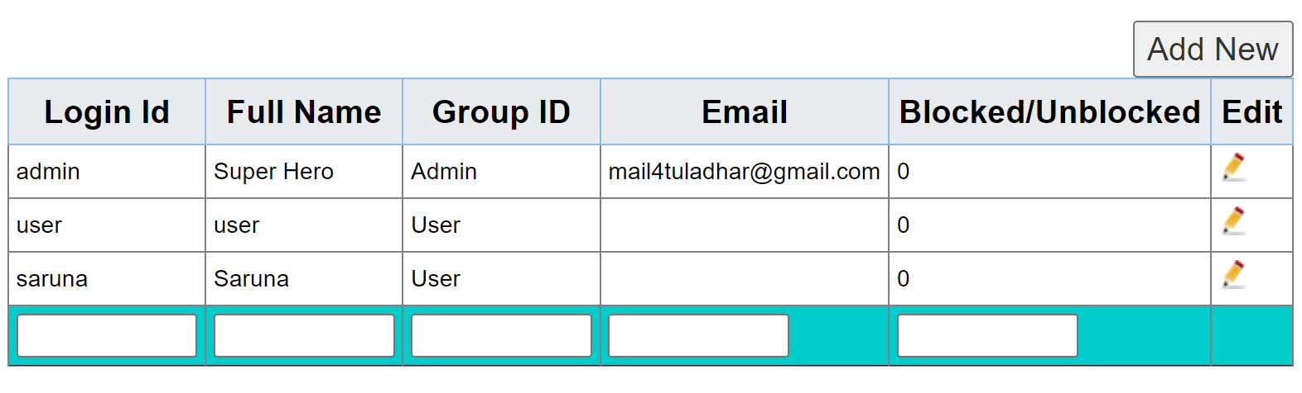
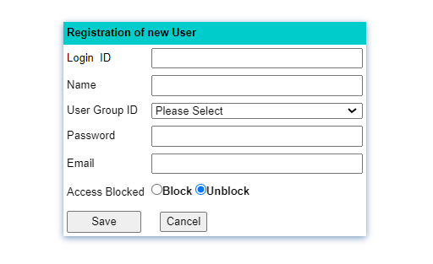

7.2. Setting
This module contains one menu i.e. Organization Setting.
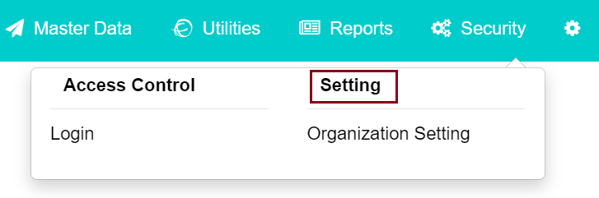
Click on the Organization setting menu.
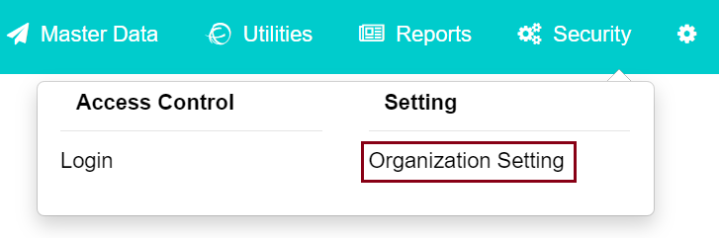
The Organizational Detail menu contains Organizational Details, Invoice Detail, and SMS Detail.
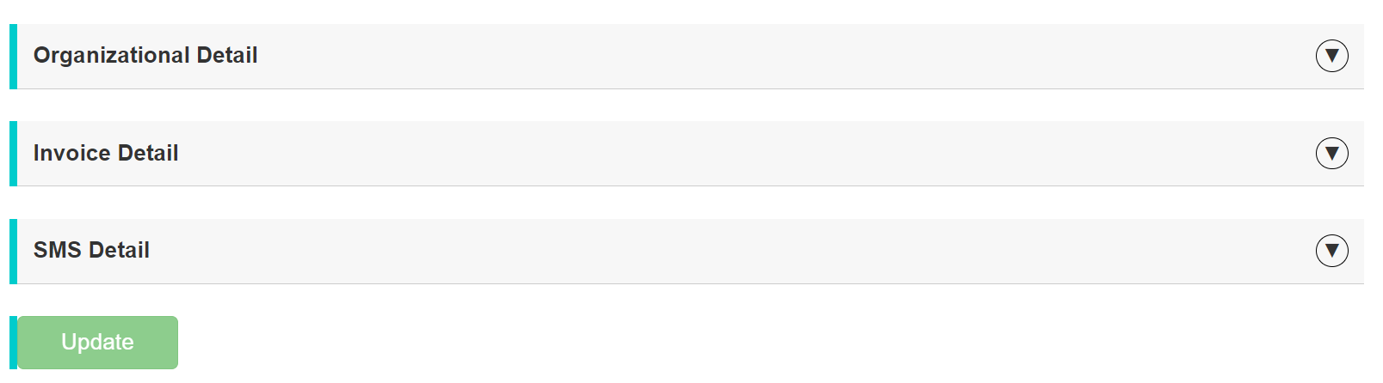
Click on the Organizational Detail then the following table is generated, in this table, you can add your organization details.
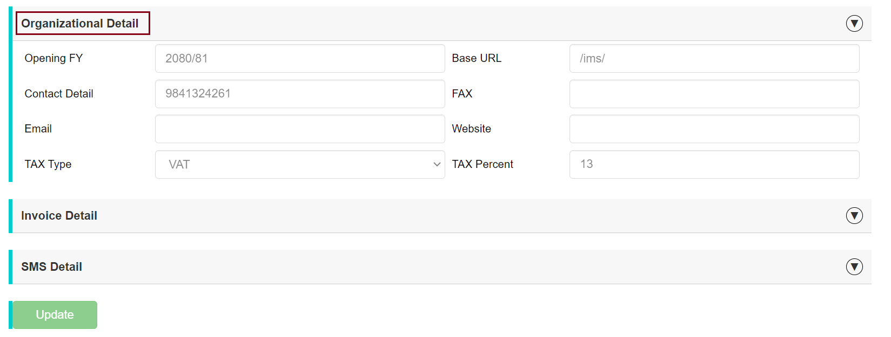

Click on the Invoice Detail then the following table is generated where you can enter Invoice detail.
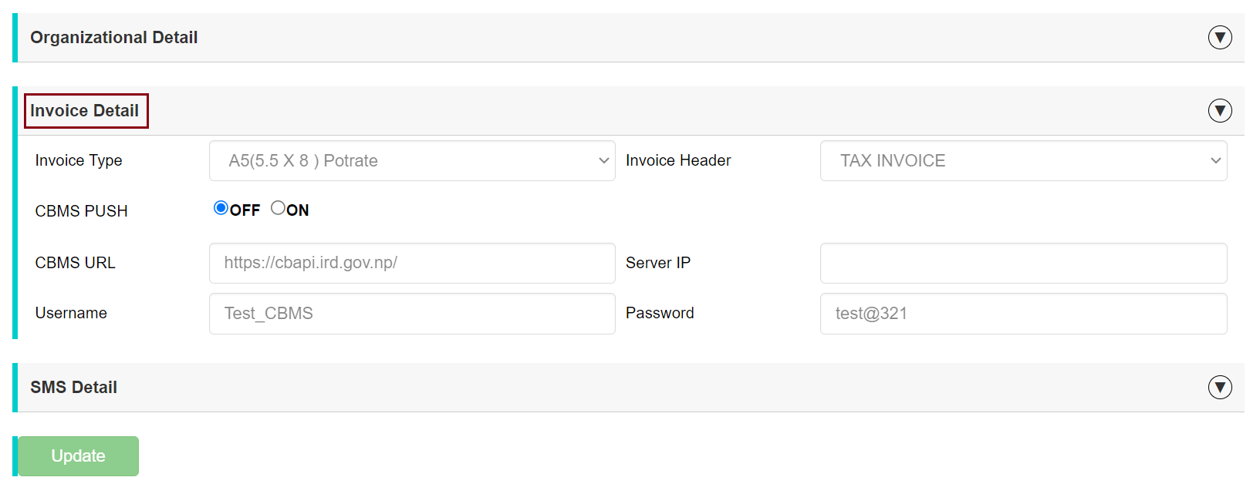

Click on the SMS Detail, here you can add SMS details.
